H32 Engineering setting
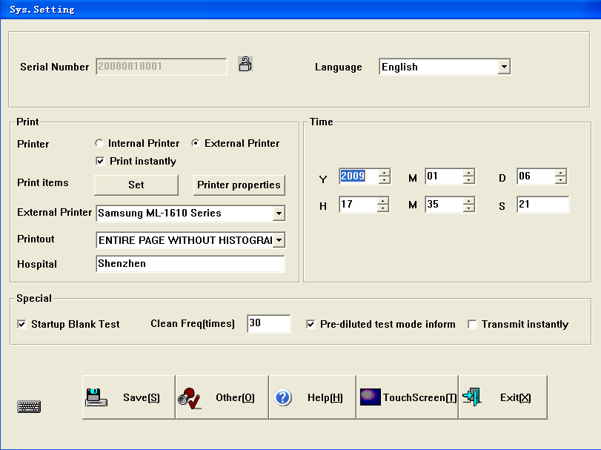
Figure 1
1. Go to the main menu, click “Setting” & click “Other” as figure 1, and then click “Log on”, the dialogue box will ask for the password, select engineer and enter the password “1001”, click “OK” as figure 2.
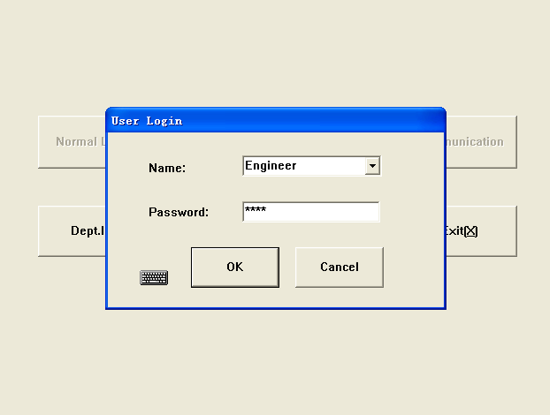
Enter”1001”
Figure 2

2. Go the main menu, click “Service” & click “Engineering adjust” as Figure 3, and then you find a picture as Figure 4 & input the engineering factors & click “Update” to save.
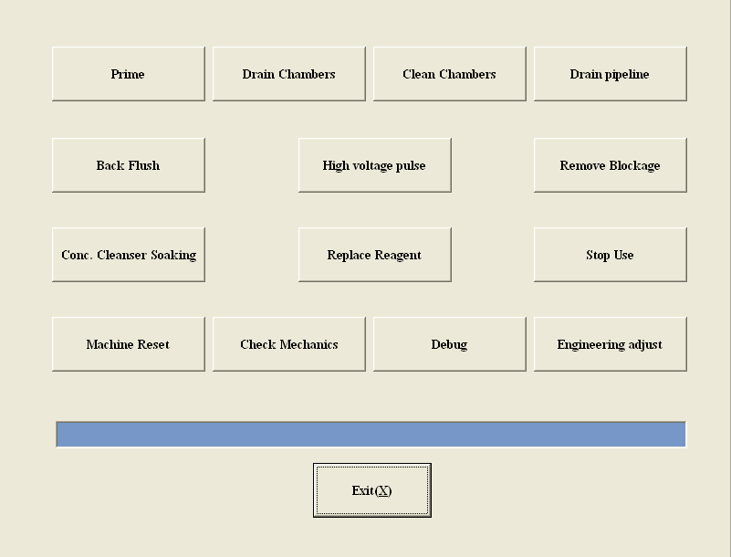
Figure 3
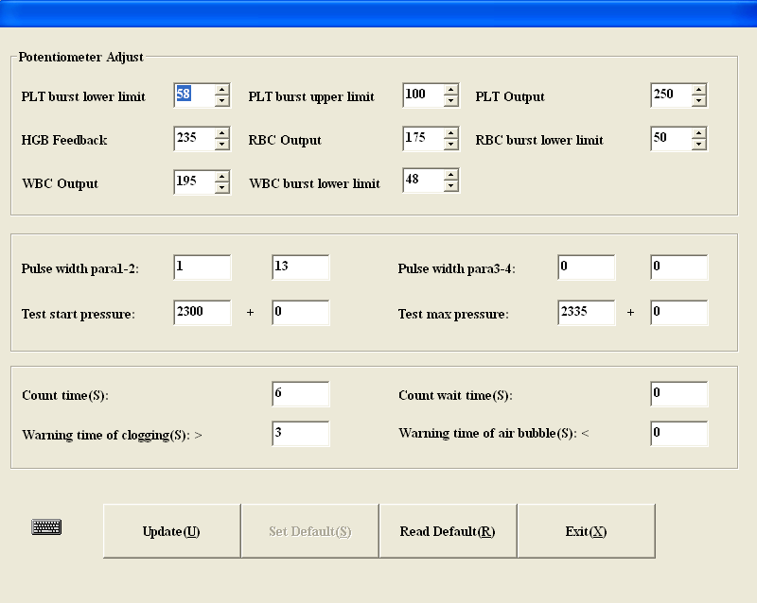
Figure 4

